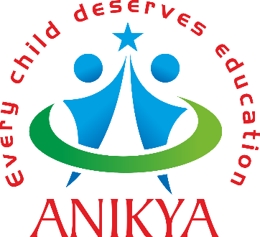 ANIKYA FOUNDATION
(Every child deserves education)

Application for Continuing Education Scholarship
Eligibility criteria:
- The combined annual income of the family should not exceed 2 lakh INR
- The student should have a minimum of 50% aggregate of marks in the previous class.

Date of Application:
- Personal details:
- Name of the Applicant:

- Date of Birth:
- Parent/Guardian/s name:
- Address for communication:

- Email ID:
- Contact Number:
- AADHAAR No.
- Parent details:
- Occupation of Parent:
- Monthly income from all sources:
- AADHAAR No.
- Address for communication:
- Contact Number:

- Education details of the applicant:
- Class presently studying:
- Class for which scholarship is applied:
- Name of the school enrolled:
- Amount of fee per annum charged by the school:

- Reason for applying for the above-named continuing education scholarship”

I hereby declare that the information provided by us in this form is correct and can be verified. I also understand the necessary criteria for applying for the above scholarships. My scholarship will be terminated if anytime, my information is found to be wrong/ my academic performance goes below the expectations/ if I get involved in any anti-social activities. I also understand that the decision of the team of ANIKYA foundation regarding this scholarship is final and we abide by their decision.

Signature of the applicant Signature of parent
Please attach the following along with your application:
- AADHAAR of student and Parent
- Enrolment letter of student from the school
- Parent Income details along with necessary proof
The application along with attachments can be emailed to info@anikyafoundation.com or anikyafoundation@gmail.com
The section below is for OFFICE use ONLY (Applicant need not fill in)
- The above application is Rejected/Approved.
- If approved, Scholarship allotted (circle the scholarship allotted):
- Kodavatiganti Bhagavan continuing education scholarships
- Gollapudi Gopala Krishna Murthy continuing education Merit scholarships
- Karri Suvarchala continuing education scholarship programs for Boys
- Rangavajhala Savitri Bright Futures education scholarship for girls
- Ramachandrula Janaki education grant for academic supplies/services

- Amount sanctioned:
- Name of the School to which the fee is paid:

- Mode of payment – (Online transfer/cheque details) :

- Academic year:
- Class:
- Applicant Referred by:

Signature of Trustee Date approved

